The Zed rostro…
A project submitted to
UKA TARSADIA UNIVERSITY
in partial fulfillment of the requirements for the degree of
Master of Science
in
Information Technology
By
Unik Zadafiya (201706100110037)
Daxit Zadafiya(201706100110040)
Guided by
Mr.Hardik shah
Assistant Professor


Babu Madhav Institute of Information Technology
Uka Tarsadia University
Bardoli – 394350
November 2019

Index
1. Definition: 1
2. Purpose and Scope 2
Purpose: 2
Scope: 2
3. Technology Used 3
Back End: 3
Front End: 3
Database: 3
4. System analysis 4
Identification of need 4
Functional and Non-functional requirement: 5
Functional requirement: 5
Non-functional: 6
Modules 7
Module 1: Login and Registration 7
Module 2: Package Management 7
Module 3: Manage Houses 7
Module 4: House Verification 7
Module 5: Contact Landlord 7
Module 6: Complain for house 7
User Characteristics 8
Admin 8
Landlord 8
Visitor/Tenant 8
Use Case Diagram: 9
Activity Diagram 10
Login: 10
10
Registration: 11
Add property: 12
Buy Package: 13
Manage Landlord: 14
14
Data Dictionary 15
RegisterNewUserData: 15
PackageDetails: 16
Tbl_House_Details: 17
UserPackageData: 18
ComplainData: 19
Tbl_Notification: 20

Definition:
- “The Zed Restro… provides facility to staff of restaurant to service easier”.

Purpose and Scope

Purpose:
The Zed Restro… provides interface for customer of restaurant to order food without need of third person. This site will provide platform for Landlord and tenant where landlord can put his/her house for rent and tenant can buy those house on rent

Scope:
Staff member and customers of hotel can access this system. Customer can order by self without need of any person using this system. Tenant can view contact details of landlord anytime by inserting required data.

Technology Used

Back End:
HTML (Mixed with ASP.NET)
CSS
JavaScript

Front End:
ASP.NET

Database:
Microsoft SQL Server 2017

System analysis

Identification of need
- The present manual system Landlord has problem in maintaining and managing their customers and their own records.
- Due to lack of computerized system most landlord have problem to manage data of property.
- Data stored based on paper so security of data is not assured.
- The present system tenants have a lots of problem to find house for rent.
- So to solve all of listed problem we developed web system that will manage data of landlord and provide platform for tenant to find houses for rent easily

Functional and Non-functional requirement:

Functional requirement:

Owner:
  - Owner can login into the system using provided id and password.
  - Owner can add, change and remove table details.
  - Owner can manage details (add, change and remove) of waiter.
  - Owner can manage category (add, change and remove) of food.
  - Owner can manage details of menu like add, change and remove.
  - Admin/Manager can cancel order.
  - Owner can view the feedback of customer.
  - Owner can view report (i.e. Order, Customer).

Admin/Manager:
  - Admin/Manager can login into the system using provided id and password.
  - Admin/Manager can add, change and remove table details.
  - Admin/Manager can manage details (add, change and remove) of waiter.
  - Admin/Manager can manage category (add, change and remove) of food.
  - Admin/Manager can manage details of menu like add, change and remove.
  - Admin/Manager can view the feedback of customer.
  - Admin/Manager can cancel order.
  - Admin/Manager can view report (i.e. Order, Customer)

Receptionist:
  - Receptionist can login into the system.
  - Receptionist can accept payment through cash/card/Net Banking.
  - Receptionist can manage status of payment like paid or unpaid.

Waiter:
  - Waiter can login into the system.
  - Waiter can manage status of food like cooked or not.

Customer:
  - Customer can insert personal details.
  - Customer can order food.
  - Customer can view menu.
  - Customer can pay bill using Cash/Card/Net banking.

Other:
  - System will generate report for food, which is most prefer by customer.
  - System will generate report for orders.
  - System will generate report for customers.

Non-functional:

Use of Algorithm for Encryption:
password and username data are store in system using simple substitution encryption algorithm.

Performance:
Easy to access and bug free

Portability:
The system is supported by all browser.

Modules

Module 1: Login and Registration
In this module Landlord and tenant can login using their username and password into the system. In this module user can view their profile details and user can also change the password in this module. In this module Admin can add, view, update, delete Landlord and tenant details.

Module 2: Package Management
Any landlord can buy or update any package as per his/her requirement. In this module Admin can add, view, update and delete any package.

Module 3: Manage Houses
The Landlord can add new house request, update existing house details, delete house and view house. Tenant can only view the details. Admin can view and delete house information.

Module 4: House Verification
Whenever Landlord want to add new house he/she will add request. In admin panel admin will check all details and then verify that request.

Module 5: Contact Landlord
Tenant can view all house as per his/her requirement. if tenant has interest in any house then he/she can contact Landlord by submitting some required data.

Module 6: Complain for house
Any tenant can complain for wrong information listed about house is incorrect or other reason. Admin will give response against those complain by possible solution. i.e. if complain is about wrong address or wrong contact detail then admin will deactivate package of Landlord and all of his/her house data.

User Characteristics
In our system we have three types of user Admin, Landlord and Tenant.

Admin
Admin can add, update, view and delete a new landlord and his/her data. Admin can manage package like add, update, view, delete. Admin can remove any Landlord and his/her package if he/she has more than 5 complain against him.

Landlord
Landlord can log into the system. Landlord can buy or update any package as per his/her requirement. Landlord can put his/her house for rent on site by giving details of house and verifying package. Landlord can manage details of his/her house.

Visitor/Tenant
Visitor can only show our site and view houses by applying search/advanced search. if visitor has interest in any house then he/she can contact Landlord by submitting some required data.

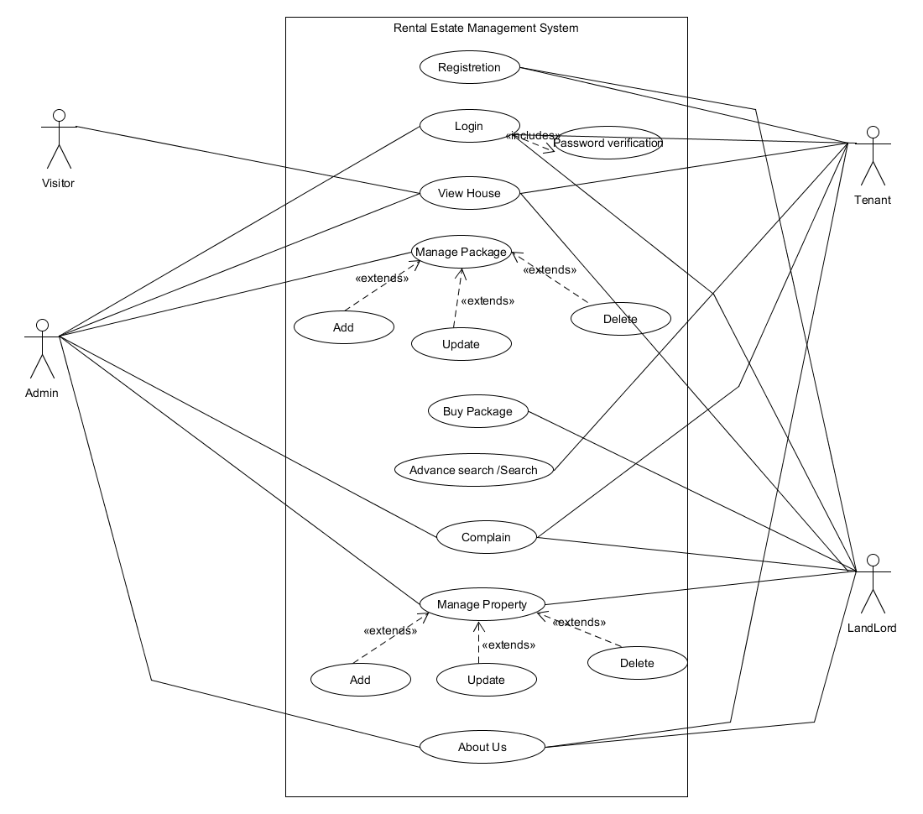
Use Case Diagram:

Activity Diagram

Login:
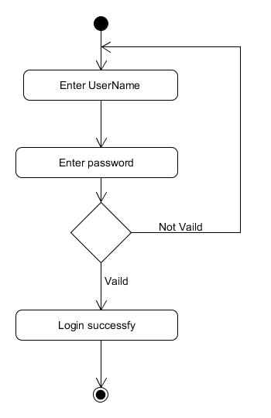

Registration:

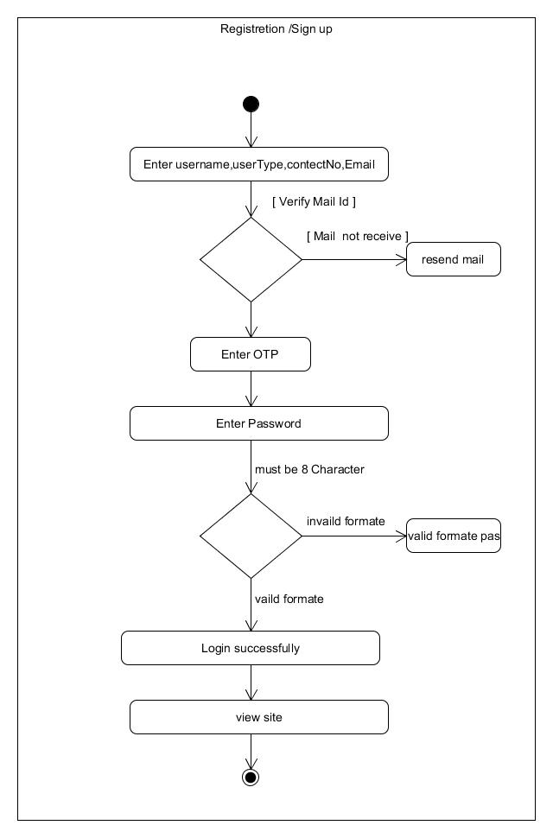

Add property:
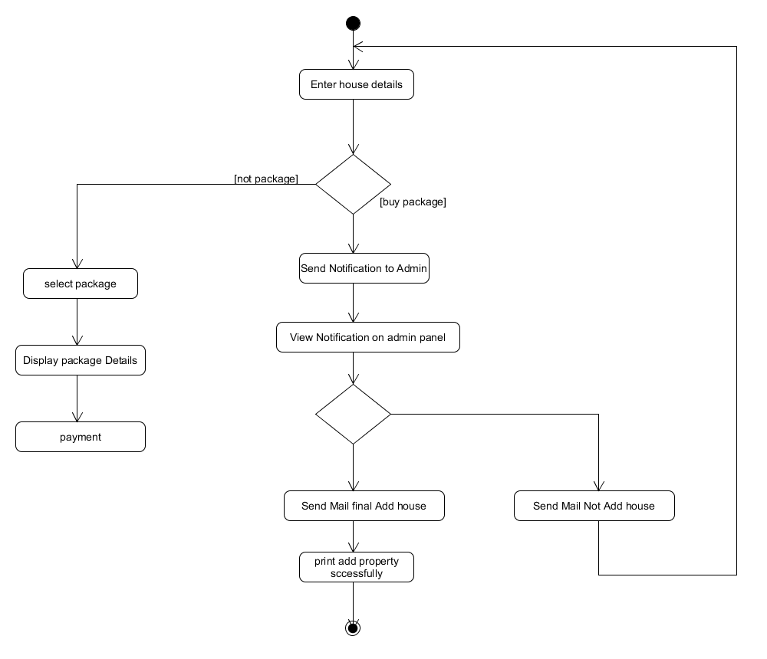

Buy Package:
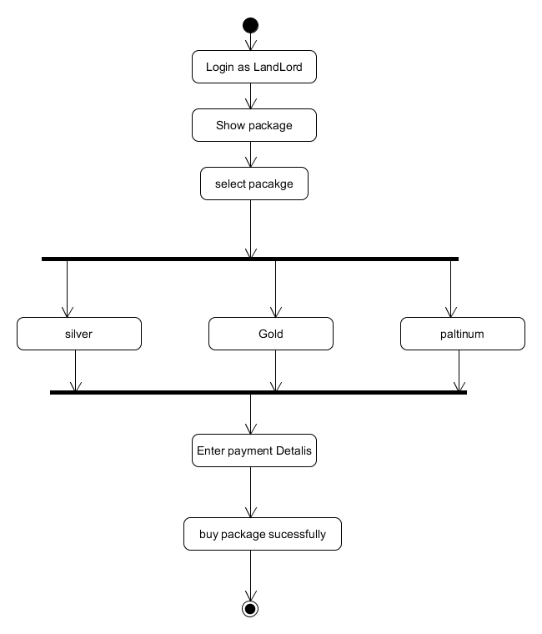

Manage Landlord:
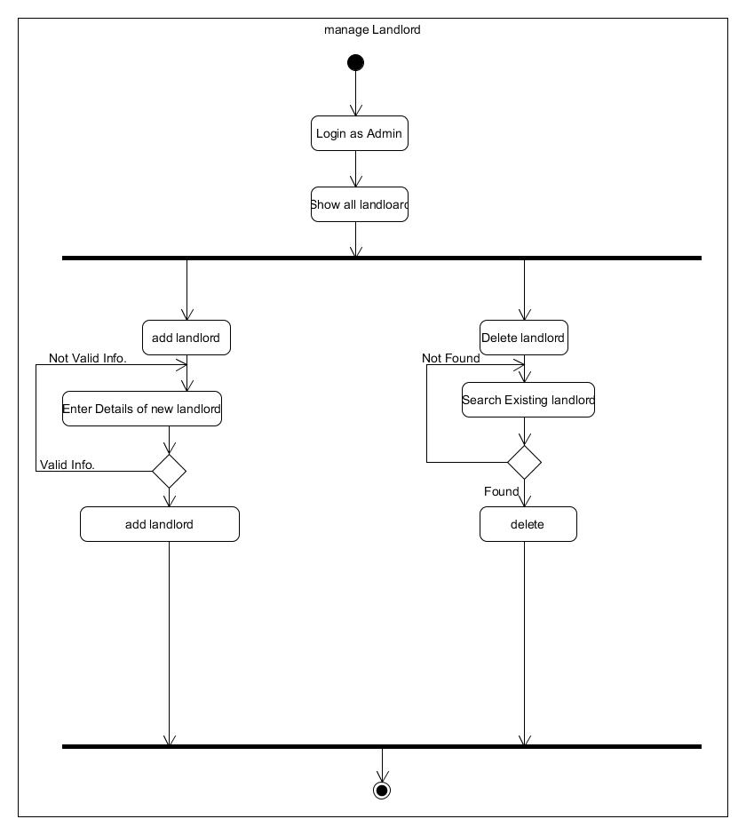

Data Dictionary

Table_Details:
No. | Field Name | Data Type | Size | Constraint | Description
1. | RegId | Int | 4  Bytes | PRIMARY KEY | Login Id of Landlord or Tenant
2. | UserName | Varchar(20) |  | Not null,  Unique | User Name for Login or authentication.
3. | Password | Varchar(20) |  | Not null | Password for authenticate user, who login into the system.
4. | UserType | Char(8) |  | Not null,  Check UserType IN (‘Tenant’,’Landlord’,’admin’) | Type of user for system.
5. | MobileNo | Varchar(14) |  | Not null | Contact number of user to reset password.
6. | Gmail | Varchar(25) |  | Not null | Email id of user to reset password.
7. | Address | Varchar(60) |  | Not Null | Address of user.
8. | RegDate | Date |  | Not Null | Date of registration

PackageDetails:
No. | Field Name | Data Type | Size | Constraint | Description
1. | PackageId | Int | 4  Bytes | Primary key | Id of Package.
2. | PackageDetails | Varchar(8) |  | Not null | Package details.
3. | ValidTo | Varchar(15) |  | Not null | Validity of package.
4. | Amount | Int | 4  Byte | Not null | Price of Package.
5. | PackageType | Char(10) |  | Not null | Type of package.

Tbl_House_Details:
No. | Field Name | Data Type | Size | Constraint | Description
1. | Property_id | Int | 4  Bytes | Primary key,  Auto_Increment | Id of House.
2. | UserName | Varchar(30) |  | Not null | It Contains name of landlord.
3. | MobileNo | Varchar(14) |  | Not null | Contact number of landlord for contact to tenant.
4. | Email_Id | Varchar(25) |  | Not null | Email id of Landlord.
5. | HouseNo | Varchar(30) | 4  Bytes | Primary key,  Auto_Increment | House no.
6. | StreetName | Varchar(30) |  | Not null | It Contains name of Street.
7. | Landmark | Varchar(14) |  | Not null | Landmark.
8. | State | Varchar(15) |  | Not null | State name.
9. | City | Varchar(30) |  | Not null | City name.
10. | Total_BedRoom | Varchar(30) |  | Not null | Total bedrooms.
11. | Total_BathRoom | Varchar(30) |  | Not null | Total Number Of Bath rooms.
12. | Total_Balcony | Varchar(14) |  | Not null | Total number of balcony.
13. | Furnished_Status | Varchar(15) |  | Not null | Furniture status of house.
14. | RoadWidth | Varchar(15) |  | Not null | Width of road near house.
15. | Cover_Area | Varchar(30) |  | Not null | Area of house.
16. | House_Condition | Varchar(14) |  | Not null | Condition of House.
17. | Possession_Status | Varchar(25) |  | Not null | Possession status.
18. | Price | Int |  | Not null | Price of house.
19. | house_Image | Varchar(30) |  | Not null | Image of house.
20. | About_house | Varchar(20) |  | Not null | Extra details of house.
21. | Insert_Date | Date |  | Not null | Insert date of house.
22. | Update_date | Date |  | Not null | Update date of house if available.
23. | Delete_date | Date |  | Not null | Delete date of house.
24. | Index_Copy_Image | Varchar(20) |  | Not null | Index copy image
25. | User_ID | Int | 4  Byte | Foreign key | User id.
26. | Status | Char(1) |  | Not null | Delete status of house.

UserPackageData:
No. | Field Name | Data Type | Size | Constraint | Description
1 | PackageId | Int | 4  Bytes | Foreign key | It contains id of package.
2. | UserId | int | 4  Bytes | References LandlordData (LandlordId), | Id of landlord.
3. | PackageBuydata | Date |  | Not null | Package purchase date.
4. | ValidToDate | Date |  | Not Null | Expire date of package.
5. | Price | Int | 4  Byte | Not Null | Price of package.
6. | Status | Varchar(15) |  | Not null | Package status.
7. | PackagePurchaseId | int | 4  Byte | Not null, | Number of package table data.

ComplainData:
No. | Field Name | Data Type | Size | Constraint | Description
1. | ComplainId | Int | 4  Bytes | Not null,  Unique,  Auto_Increment | This field is used for complain id.
2. | LandlordId | int | 4  Bytes | References LandlordData (LandlordId) | It contains landlord id of landlord.
3. | ComplainType | Varchar(20) |  | Not null | It contains type complain.
4. | Description | Varchar(80) |  | Not null | It contains the description of complain.
5. | UserId | int | 4  Bytes | Not null,  References LoginData  (UserId), | Id of user who register complain.
6. | ComplainDate | Date | 3  Bytes | Allow null | Date when user register complain.

Tbl_Notification:
No. | Field Name | Data Type | Size | Constraint | Description
1. | NotificationId | Int | 4  Bytes | Not null, | This field is used for notification id.
2. | NotificationDate | Date |  | Not null | Date of notification.
3. | userName | Varchar(20) |  | Not null | User name.
4. | User_id | Int | 4  Byte | Not null | User id.

